# Task Manager API Documentation

Base URL: http://localhost:9090/api/tasks

## 1. Create a Task

**Endpoint:** POST /api/tasks  
**Description:** Create a new task with a title and description.

**Request Body:**

{  
 "title": "Task title",  
 "description": "Task description"  
}

**Response (201 Created):**

{  
 "id": 1,  
 "title": "Task title",  
 "description": "Task description",  
 "completed": false  
}

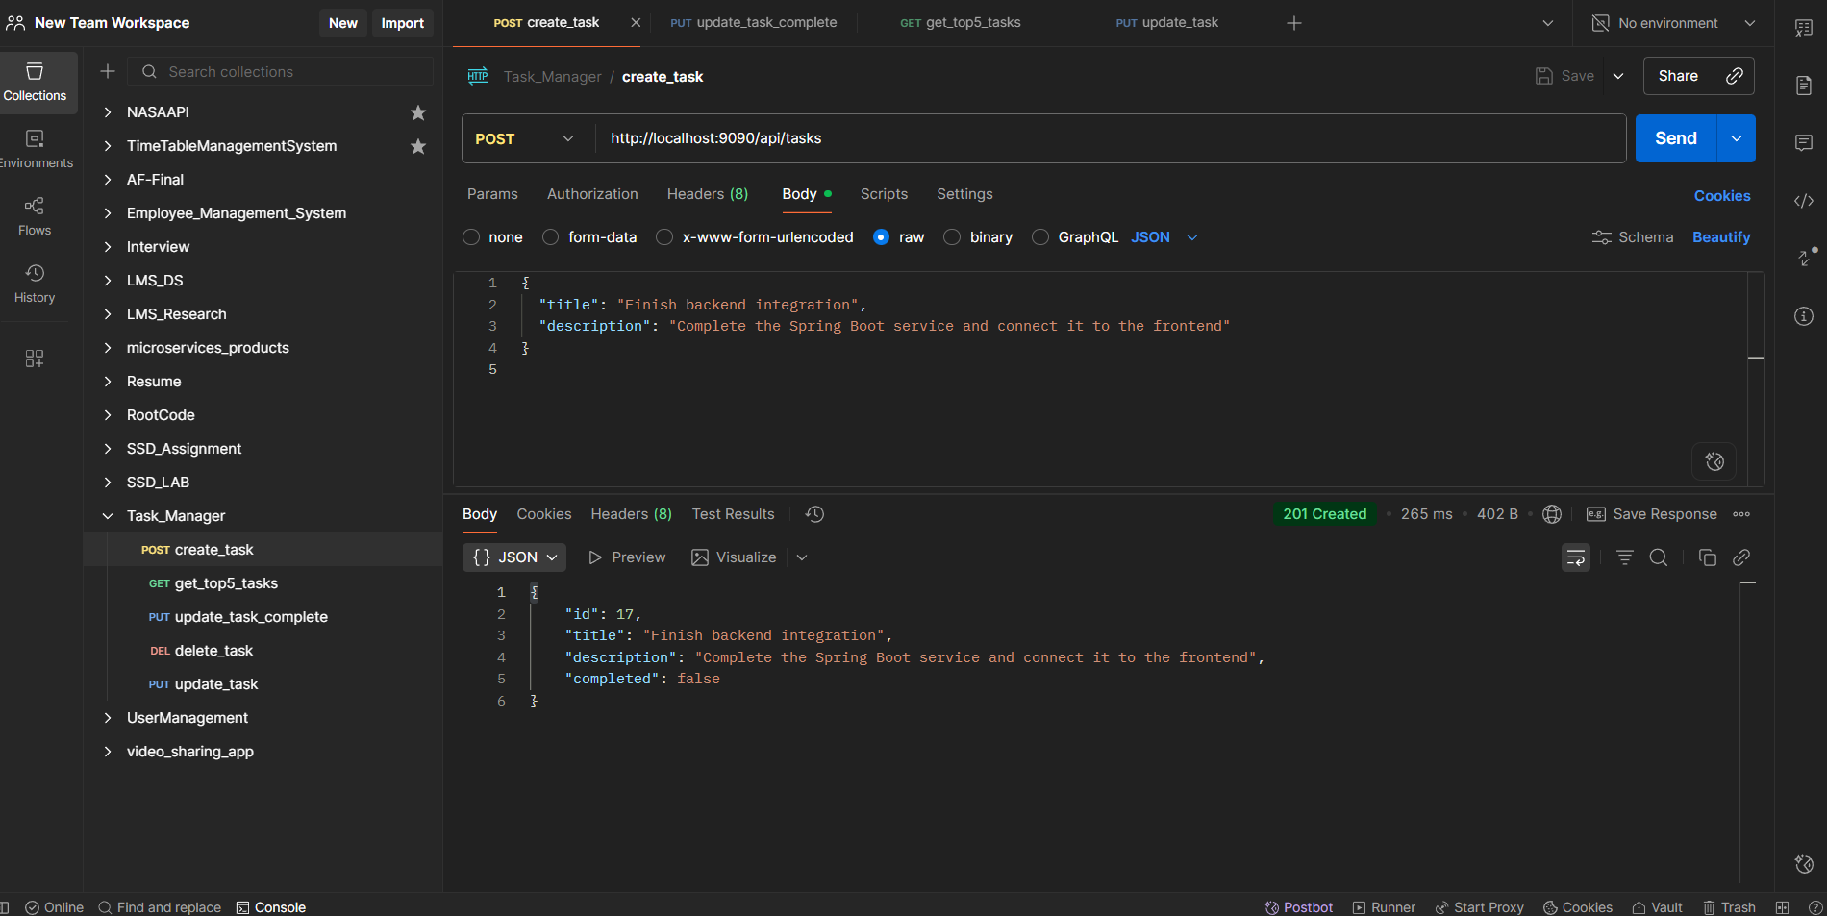

**Error Responses:**

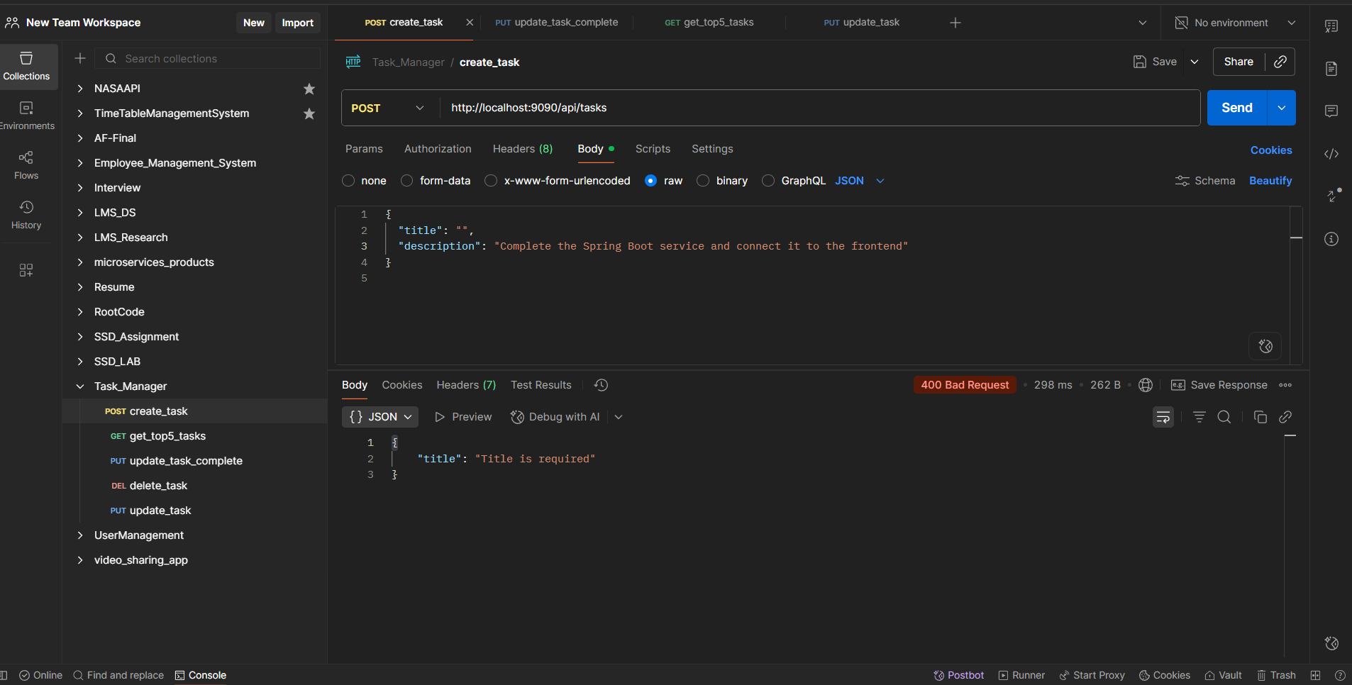

| Status | Message |
| --- | --- |
| 400 | Validation errors (empty title/description) |
|  |  |

## 2. Get Recent Tasks

**Endpoint:** GET /api/tasks/recent  
**Description:** Retrieve the 5 most recent incomplete tasks.

**Response (200 OK):**

[  
 {  
 "id": 1,  
 "title": "Task title",  
 "description": "Task description",  
 "completed": false  
 },  
 {  
 "id": 2,  
 "title": "Another Task",  
 "description": "Description",  
 "completed": false  
 }  
]

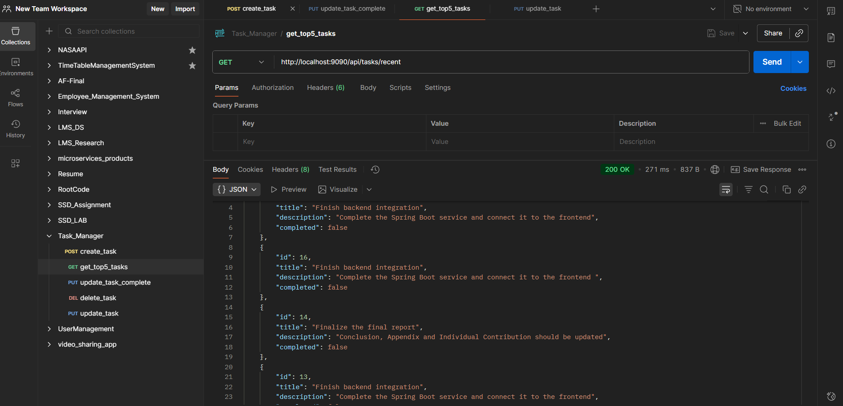

## 3. Update a Task

**Endpoint:** PUT /api/tasks/{id}  
**Description:** Update the title and description of an existing task.

**Path Parameters:**

| Parameter | Type | Description |
| --- | --- | --- |
| id | Long | ID of the task to update |

**Request Body:**

{  
 "title": "Updated title",  
 "description": "Updated description"  
}

**Response (200 OK):**

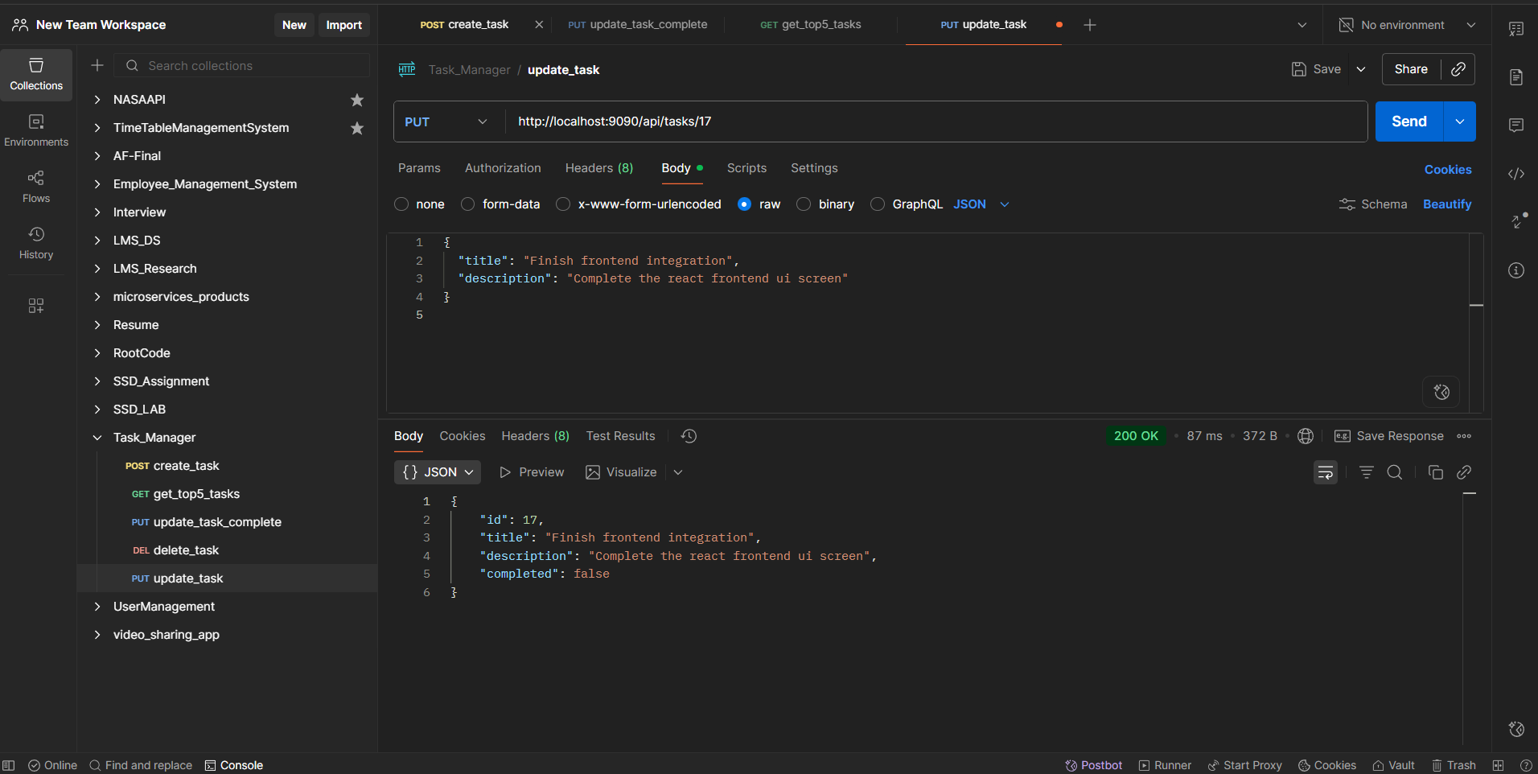

{  
 "id": 1,  
 "title": "Updated title",  
 "description": "Updated description",  
 "completed": false  
}

**Error Responses:**

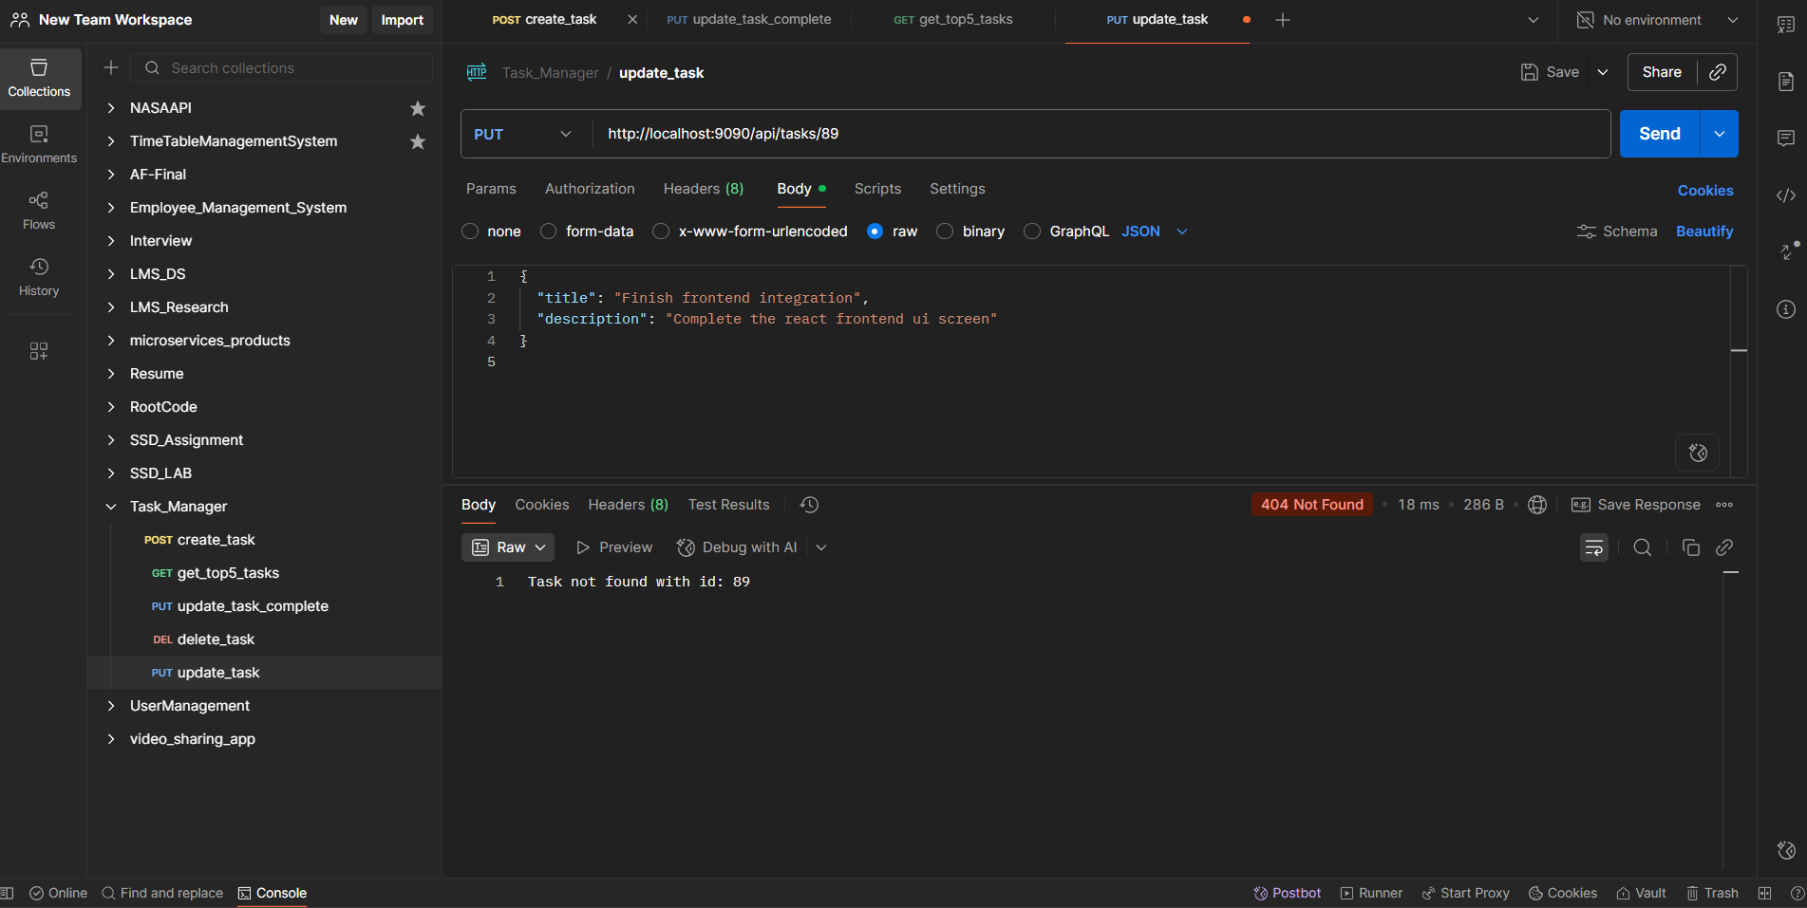

| Status | Message |
| --- | --- |
| 404 | Task not found with id: {id} |

## 4. Mark Task as Completed

**Endpoint:** PUT /api/tasks/{id}/complete  
**Description:** Mark a task as completed.

**Path Parameters:**

| Parameter | Type | Description |
| --- | --- | --- |
| id | Long | ID of the task |

**Response (200 OK):**

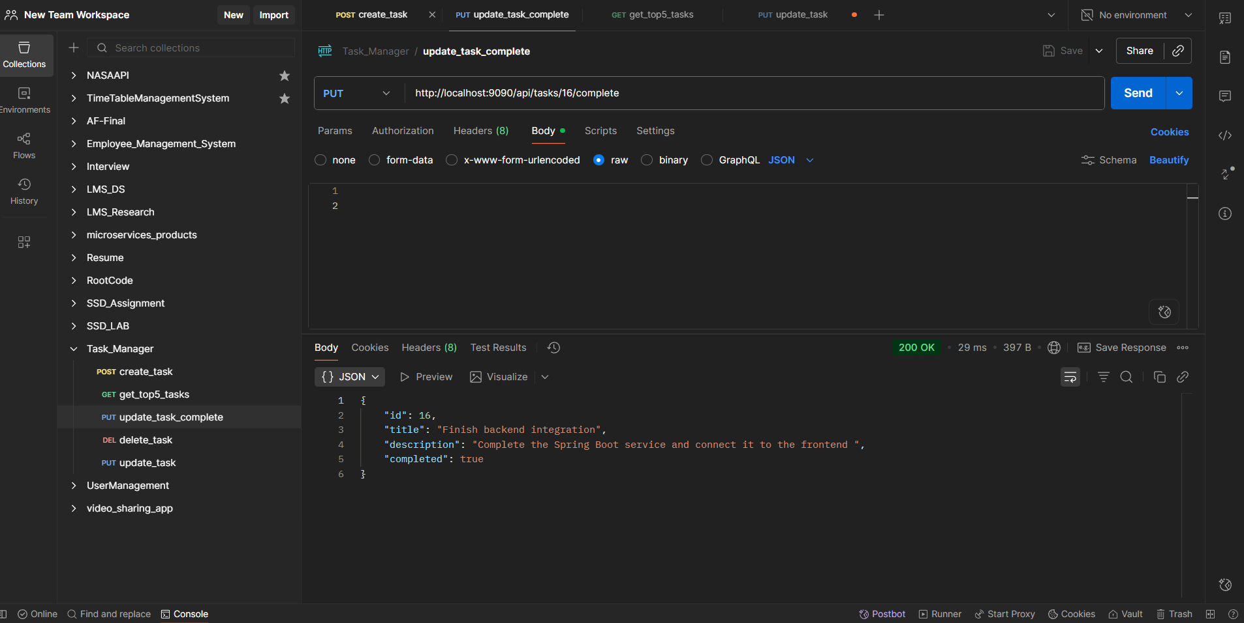

{  
 "id": 1,  
 "title": "Task title",  
 "description": "Task description",  
 "completed": true  
}

**Error Responses:**

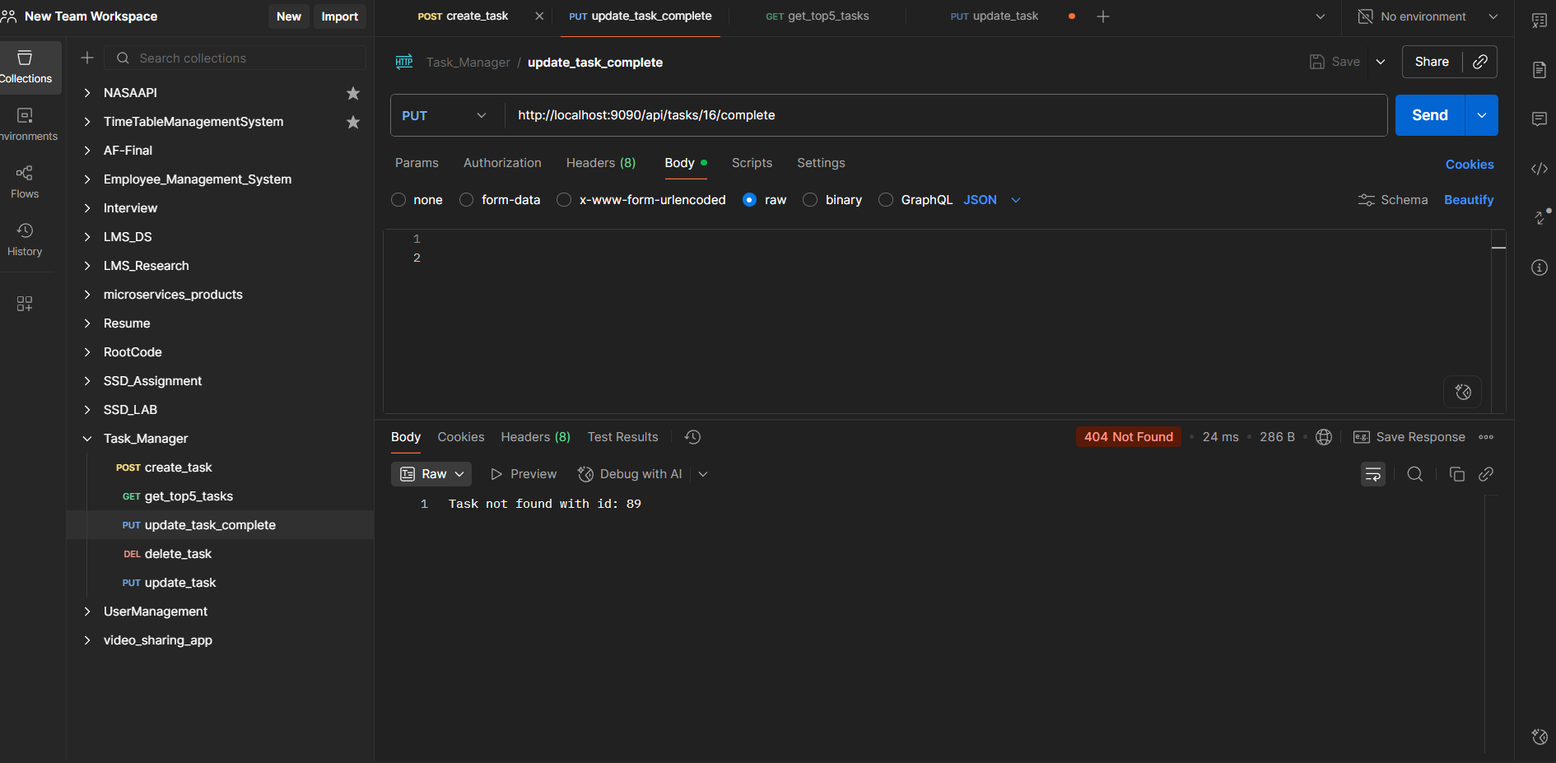

| Status | Message |
| --- | --- |
| 404 | Task not found with id: {id} |

## 5. Delete a Task

**Endpoint:** DELETE /api/tasks/{id}  
**Description:** Delete a task by its ID.

**Path Parameters:**

| Parameter | Type | Description |
| --- | --- | --- |
| id | Long | ID of the task |

**Response (200 OK):**

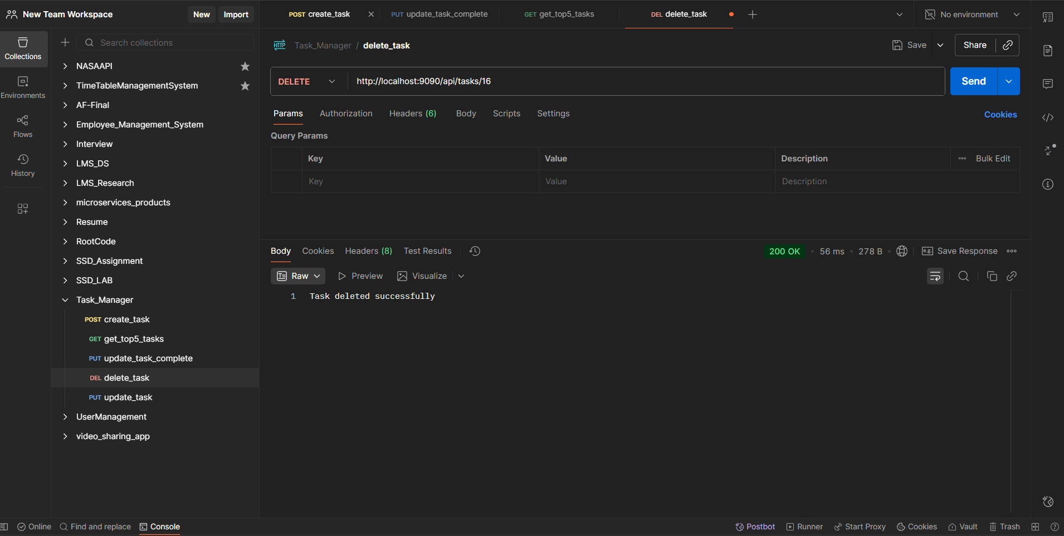

Task deleted successfully

**Error Responses:**

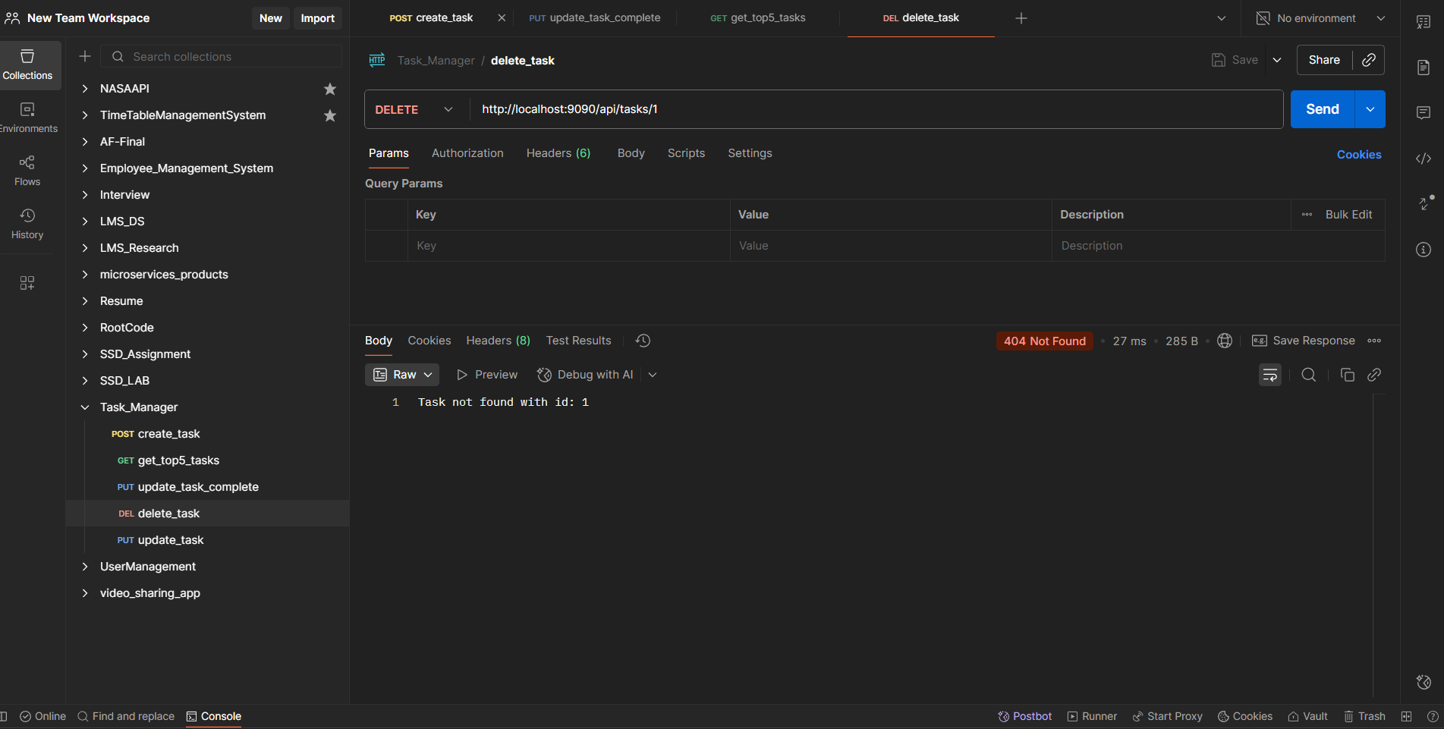

| Status | Message |
| --- | --- |
| 404 | Task not found with id: {id} |

## Notes

1. **Validation:**
   * title and description fields are required when creating/updating tasks.
2. **Error Handling:**
   * For non-existent task IDs, the API returns a 404 Not Found with a descriptive message.
3. **CORS:**
   * Frontend is allowed to access these endpoints from http://localhost:3000.